To find an equilibrium state where we obtain maximal GDP Growth rate yet use the resources optimally, a best fit linear regression model is utilized. The model is given as,
$${GDP}_{i}=β_{0}+β_{1 }{Cons}_{i}+β_{3} {Cons}_{i}^{2}+β_{4}{ Inv}_{i}+β_{5}{ Inv}_{i}^{2}+β_{6}{ Income}_{i}+β_{7}{ Income}_{i}^{2}+ε_{i}$$
Where,
${Cons}_{i}$ - Consumption Expenditure
${ Inv}_{i}$ - Investments
${ Income}_{i}$ - Income per capita
$i$ - No of samples (1….n)
Using sensitivity analysis, optimal constraints for resources is identified, assuming constant increments of each resource and keep the rest unchanged. Using Sensitivity Plots, growth of each resource is plotted against GDP Growth rate. (Fig 1)
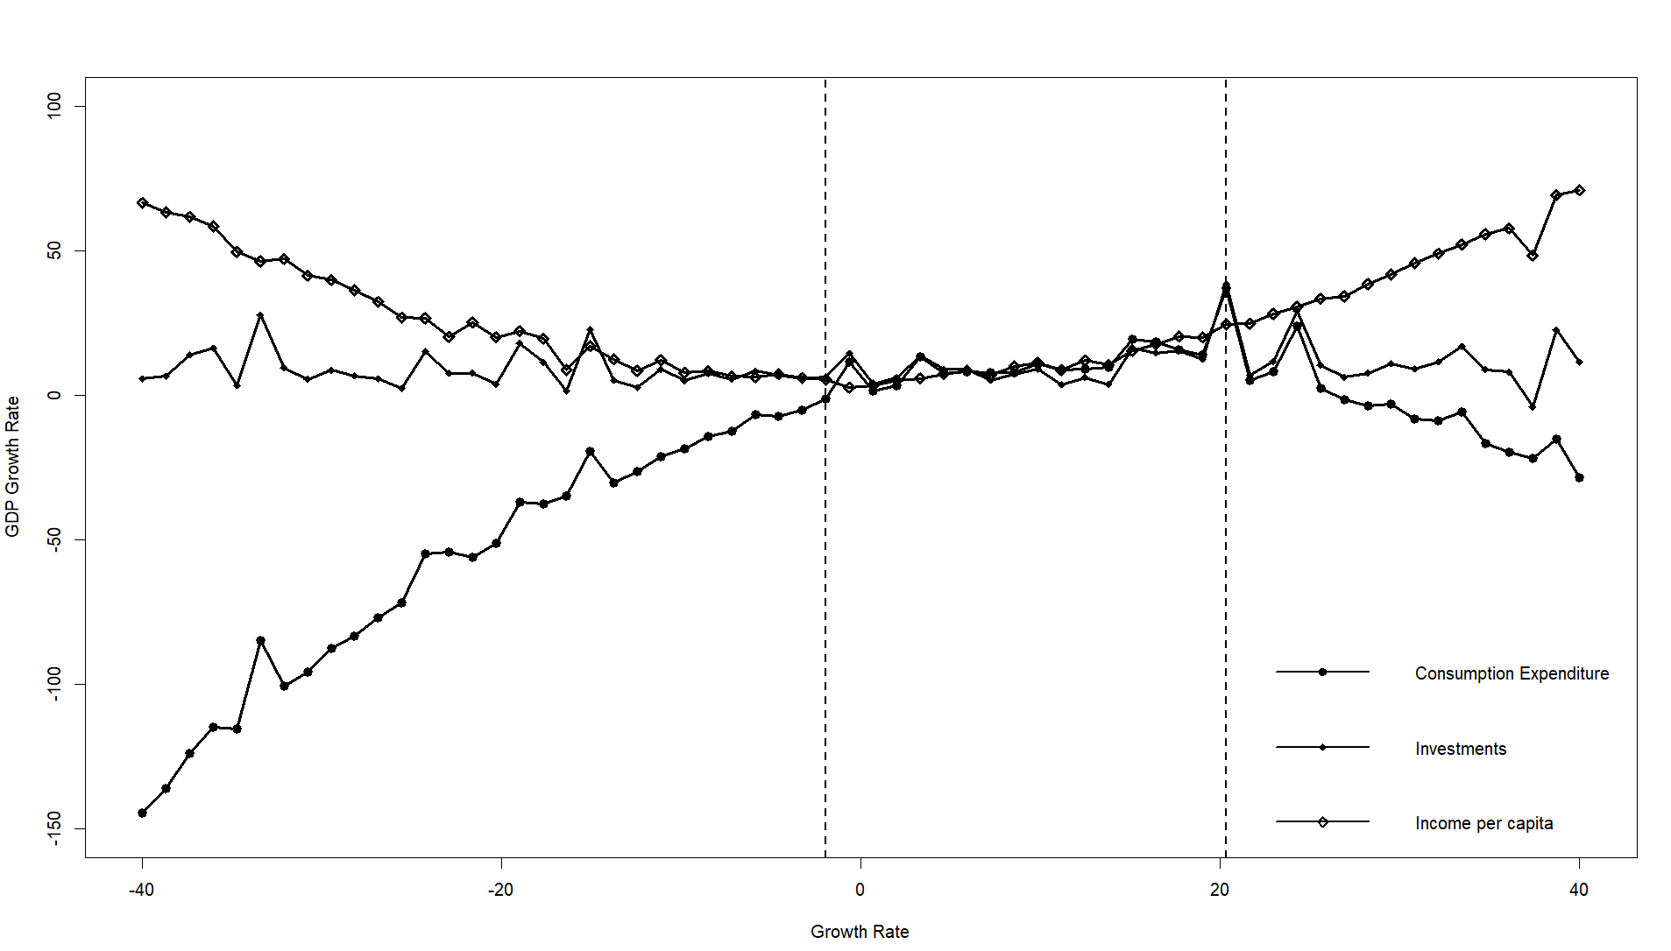
The graph represents the resource growth rate while keeping the other constraints unchanged against GDP Growth rate. We can see that the GDP growth rate peaks at 20% of Consumption Expenditure, followed by a decline. For Investments, the GDP Growth Rate almost remains constant except a few irregular peaks and troughs which may represent investment outliers due to unforeseen events like, COVID, wars, economic/financial crisis etc. We see a steady decline followed by a steady increase in GDP Growth rate with Growth in Income per capita.
Thus, from this graph we have inferred that we can establish a point where all the components stay in harmony while having an increased GDP Growth rate. Although the graph seems like meets at around 7-8% growth rate for optimality, we can establish a region where the components may not exactly meet, but still remain within fair neighbourhood of each other such that we can give wider margins of growth.
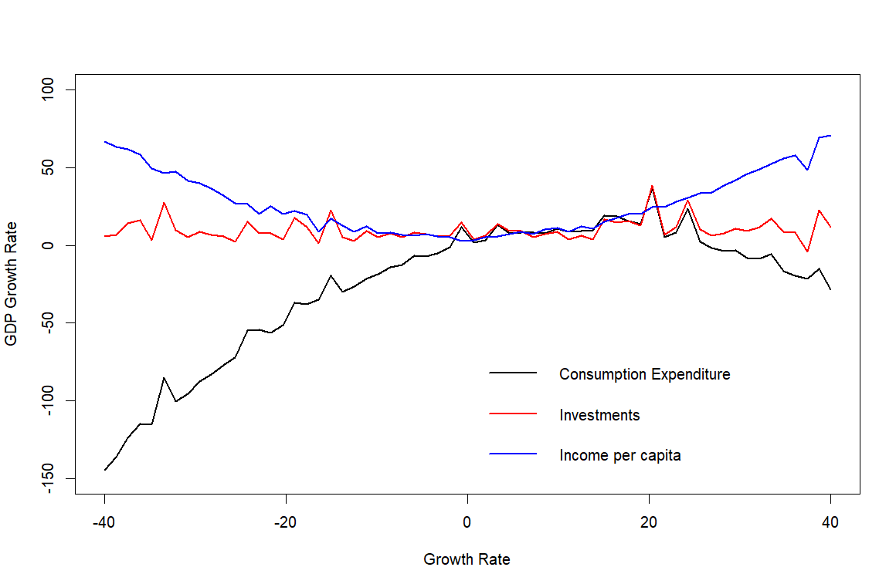
This specific region shows -1.26% to 24.45% GDP growth rate with different variations of the components might give an optimal region.

